LW: Image Manipulation with Classes

# Objectives

* Address problems when using dynamic memory in classes
  + Avoid memory leaks
  + Enable deep copy (i.e. avoid shallow copy)
  + Hint: Rule of Three
* See how image structure changes when implemented with classes

# Overview

After learning all about classes, your friend wrote a program to put image information into classes. They created an image class and converted the pixel struct into a proper class.

As you run and play with the program you notice some peculiarities.

* First you load this image of reveille.[1]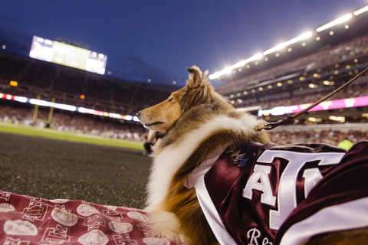
* Then you convert it to grayscale..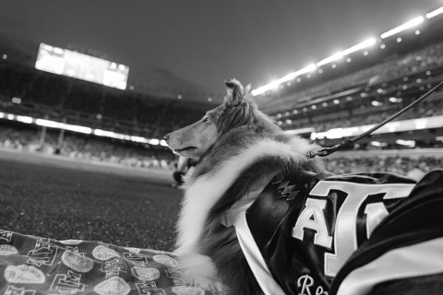
* Then you add the Color (225, 5, 5).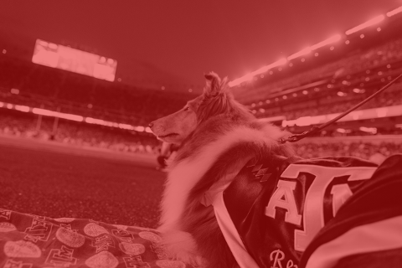
* This seems pretty cool. You exit the program and decide to play with it some more. So you load the image of Reveille again. You decide to replicate the colored image you had before, so you add the Color (255, 5, 5) again.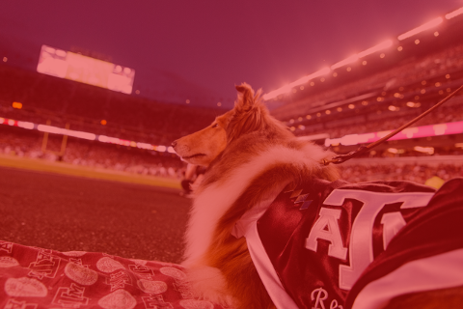
* You notice that there is evidence of other colors besides red whereas last time it was all shades of red. You suspect something may be wrong with the program. You realize that your friend put the image on the heap, so maybe a shallow copy is the culprit.
* On top of all that, you find out that there are memory leaks in the program. You see a clear() function that could be called from a destructor, but you suspect that there is a problem with it that needs to be fixed.

# Requirements

* Download the [starting code](https://drive.google.com/drive/folders/1cP32OeJchZ2TDwavaCu-sbMEX3MqsuP1?usp=share_link) along with some ppm images you can use.[2]
  + manip.cpp
    - Do not edit this file.
  + functions.h
    - Do not edit this file.
  + functions.cpp
    - Do not edit this file.
  + Image.h
    - Edit this file.
    - Add rule of 3 functions
  + Image.cpp
    - Edit this file.
    - Modify clear function
    - Define rule of 3 functions
  + Pixel.h
    - Do not edit this file.
  + Pixel.cpp
    - Do not edit this file.
* Update the image class to implement the rule of three and update any functions used by the rule of three that might be broken.

# Supporting Information

Feel free to look back at the prior lab work on Image Manipulation if needed.

### Viewing PPM files

You’ll need to view your PPM files to see the results of your program. Unfortunately, PPM is not supported by many image viewers.

Some options for viewing your files include:

* [Drag files onto this website (http://paulcuth.me.uk/netpbm-viewer/)](http://paulcuth.me.uk/netpbm-viewer/)
  + You don’t have to download any programs!
* [The GIMP](https://www.gimp.org/) is an open source version of Photoshop.
  + ***Warning:*** This is a very large program.

1. [Image taken from https://tamu.photoshelter.com/gallery-image/Reveille/G000095v1nAlxlLA/I0000pjQsaUrGSxY/C0000plgky6s4_tk](https://tamu.photoshelter.com/gallery-image/Reveille/G000095v1nAlxlLA/I0000pjQsaUrGSxY/C0000plgky6s4_tk)
2. [Images taken from https://photos.tamu.edu/](https://photos.tamu.edu/)